FALLBROOK REGIONAL HEALTH DISTRICT

FOUNDATION

AGENDA

REGULAR BOARD MEETING

Wednesday, May 12, 2021, Approximately 7:00 p.m.

In accordance with the current State of Emergency and the Governor’s Executive Order N-25-20, of March 12, 2020 and N-33-20 of March 19, 2020, teleconferencing will be used for this meeting. Board members, staff and members of the public will be able to participate by webinar by using the following link: https://us02web.zoom.us/j/83999364665?pwd=RWl4N0hPd3l5c2MxZ1pLVkFZRFprZz09. Please use the information below if you do not join via the link above: Meeting ID: 839 9936 4665 Password: 7T3ZWL . Participants will need to download the Zoom app on their mobile device. Members of the public will also be able to participate by telephone using the following dial in information: Dial in #: (310) 372-7549 Passcode 660448.

CALL MEETING TO ORDER / ROLL CALL / ESTABLISH A QUORUM / PLEDGE OF ALLEGIANCE

B. APPROVAL OF THE AGENDA

C. PUBLIC COMMENTS

Opportunity for board members and citizens to speak on items of interest within subject matter jurisdiction of the Foundation. Please note that, for comments made on items not appearing on the current agenda, the Board may take no action as to the comment at the current meeting (Gov’t Code 54954.3[a]), and the Board is allowed only a brief response to the speaker’s comment. For the record, please state your name. “Request to speak” cards should be filled out in advance and presented to the Board Chair or the recording secretary. The Board has a policy limiting any speaker to not more than five minutes

D. DISCUSSION/POSSIBLE ACTION ITEMS
D1. Consideration of the Ratification of the Articles of Incorporation of the Fallbrook Regional Health District Foundation 2
D2. Consideration of the Ratification of the Bylaws of the Fallbrook Regional Health District Foundation 4

E. ADJOURNMENT

NOTE: I certify that on Friday, May 7, 2021 I posted a copy of the foregoing agenda near the regular meeting place of the Board of Directors of Fallbrook Regional Health District Foundation, said time being at least 72 hours in advance of the meeting. The American with Disabilities Act provides that no qualified individual with a disability shall be excluded from participation in, or denied the benefits of District business. If you need assistance to participate in this meeting, please contact the District office 24 hours prior to the meeting at 760-731-9187.
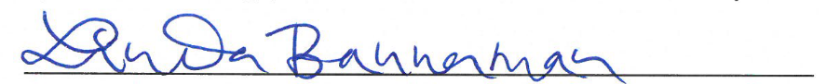

Board Secretary/Clerk

